Five Process Groups:

1. Scoping Process Group (which PMI calls the Initiating Process Group)

■Identifying stakeholders

■ Recruiting the project manager

■ Eliciting the true needs and high-level requirements of the client

■ Documenting the client’s needs

■ Writing a one-page description of the project

■ Gaining senior management approval to plan the project

1. Planning Process Group

■ Defi ning all of the work of the project

■ Estimating how long it will take to complete the work

■ Estimating the resources required to complete the work

■ Estimating the total cost of the work

■ Sequencing the work

■ Building the initial project schedule

■ Analyzing and adjusting the project schedule

■ Writing a risk management plan

■ Documenting the project plan

■ Gaining senior management approval to launch the project

1. Launching Process Group (which PMI calls the Executing Process Group)

■ Recruiting the project team

■ Writing a project description document

■ Establishing team operating rules

■ Establishing the scope change management process

■ Managing team communications

■ Finalizing the project schedule

■ Writing work packages

1. Monitoring and Controlling Process Group

■ Establishing the project performance and reporting system

■ Monitoring project performance

■ Monitoring risk

■ Reporting project status

■ Processing scope change requests

■ Discovering and solving problems

1. Closing Process Group

■ Gaining client approval of having met project requirements

■ Planning and installing deliverables

■ Writing the final project report

■ Conducting the post-implementation audit

**Risk Assessment Template**

|  |  |  |  |  |  |
| --- | --- | --- | --- | --- | --- |
| **CATEGORIES**  **AND RISKS** | **RISK SCOPE TRIANGLE ELEMENTS** | | | | |
| Scope | Time | Cost | Quality | Resources |
| Technical |  |  |  |  |  |
| Project  Management |  |  |  |  |  |
| Organizational |  |  |  |  |  |
| External |  |  |  |  |  |

**Static Risk Assessment:**

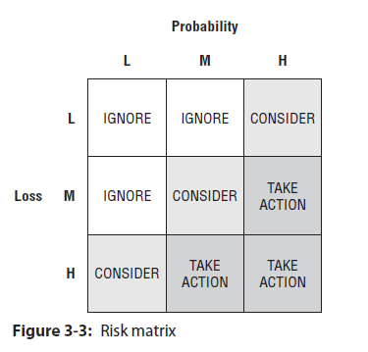

**Dynamic Risk Assessment:**

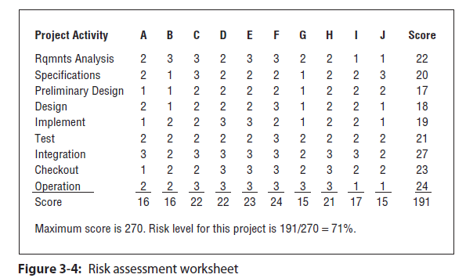

Requests for Proposals (RFPs): I recommend that your RFP contain the following:

■ Introduction

■ Business profile

■ Problem or opportunity

■ POS (optional)

■ RBS (optional)

■ Vendor responsibility

■ Contract administration

■ Instructions to vendors

■ Vendor point of contact

■ Time and cost estimates

■ Pricing

■ Evaluation criteria

**Vendor Evaluation Criteria:**

■ Corporate experience with similar work

■ Financial stability

■ Technical approach

■ Personnel experience, skills, and competencies

■ Risk management processes

■ Location

■ Applicable tools, templates, and processes

■ References for similar work

The vendor agreement typically includes the following:

■ Statement of Work for the vendor

■ Terms and conditions

■ List of deliverables, schedule, and budget

■ Defined acceptance process, including acceptance criteria

■ Identification of the project and supplier representatives responsible and authorized to agree to changes to the vendor agreement

■ Description of the process for handling requirements change requests from either side

■ The processes, procedures, guidelines, methods, templates, and so on that will be followed

■ Critical dependencies between the project and the vendor

■ Descriptions of the form, frequency, and depth of project oversight that the vendor can expect from the project, including the evaluation criteria to be used in monitoring the vendor’s performance

■ Clear definition of the vendor’s responsibilities for ongoing maintenance and support of the acquired products

■ Identification of the warranty, ownership, and usage rights for the acquired products

